8.4 Inch AV/FM/Touch/PC set
LCD Color Receiver
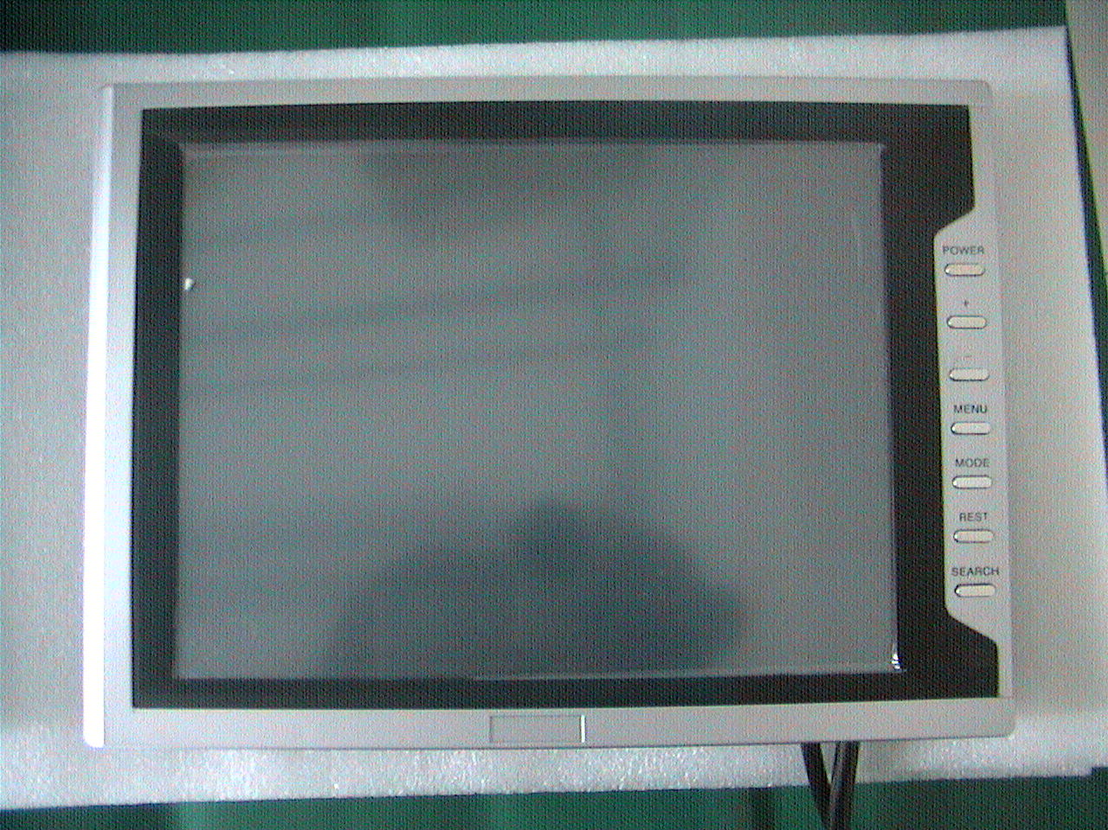

OPERATION INSTRUCTION

Table Of Contents

Specification 2
Key function 3
Remote control panel 4
Connection guide 5
Guide to install touch 6--7
Trouble shooting 8

We are very grateful to your choice of our products. To make full use of the product and to avoid malfunction. please make sure to read over, The "instruction" and comply with the items from it.
Precaution before operation
1:To ensure safety and avoid the accident, please read over the item below before installing and operating the product safety.
2:The local traffic rule must be complied with
3:Drivers are forbidden to operate the product during driving. lt increases the possibility of causing accident, please watch and operate it after stopping the car at safety place .
4:Do not insert the finger or other object into the machine body while power is on, it may damage LCD, The small components should be placed where is unavailable for children.
5:Do not touch both antenna and monitor simultaneously in the time of thunder, which may cause you electronic shook. ln the direct sunlight, the temperature in the car will increase considerably, it should be cooled down before operation
Precaution before installation
The qualified technical or maintainer are suggested to setup the LCD.
Turn off the ignition switch before installing it, or it may cause electric circle failure.
Do not damage the parts in the car like pipe, gasoline-tank and wire, which will result in flame.
Location of installation The places below are forbidden to install the product it may block the driver's view.
It may disturb driving especially operating the steering-wheel, gear shift or brake.

Specification

Product 8.4inch TFT LCD Monitor

Model XDXS084Z
Display Size 8 inch
Feature AV/PC display/FM / auto rearview system/
Touch for OSD menu and car PC
Physical Resolution 800*600RGB
High Resolution 1024*768 formatted
Rated Voltage DC11.5—14.5V(600Ma)
Electronic Consumption 10W (Max)
Audio Output 150mW
Application Temperature -20℃---+60℃
View of Angle 150°
AV Chromatic System PAL/NTSC (auto switch)
Control Bottom control/touch Control

Key function

The function of bottom on machine cover
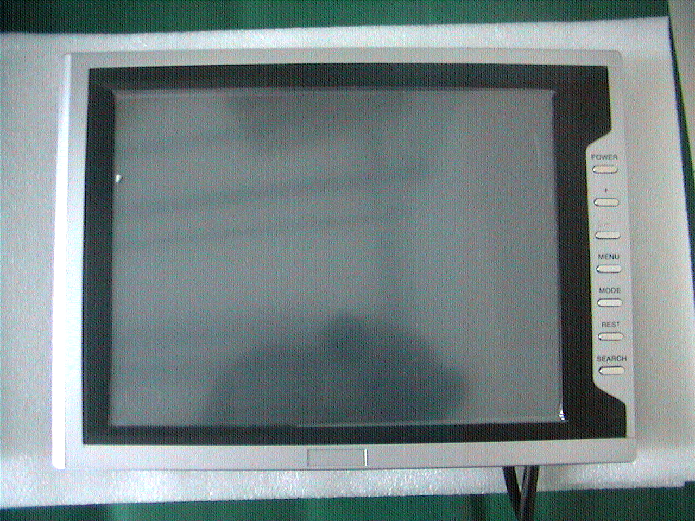
1
2
3
4

5
6
7

1:POWER SWITCH 2:VOLUME"+"
3:VOLUME"-" 4:MENU SWITCH
5:MODE SWITCH 6:REST SWITCH
7:SEARCH SWITCH
The connection jack on machine cover

Remote control panel
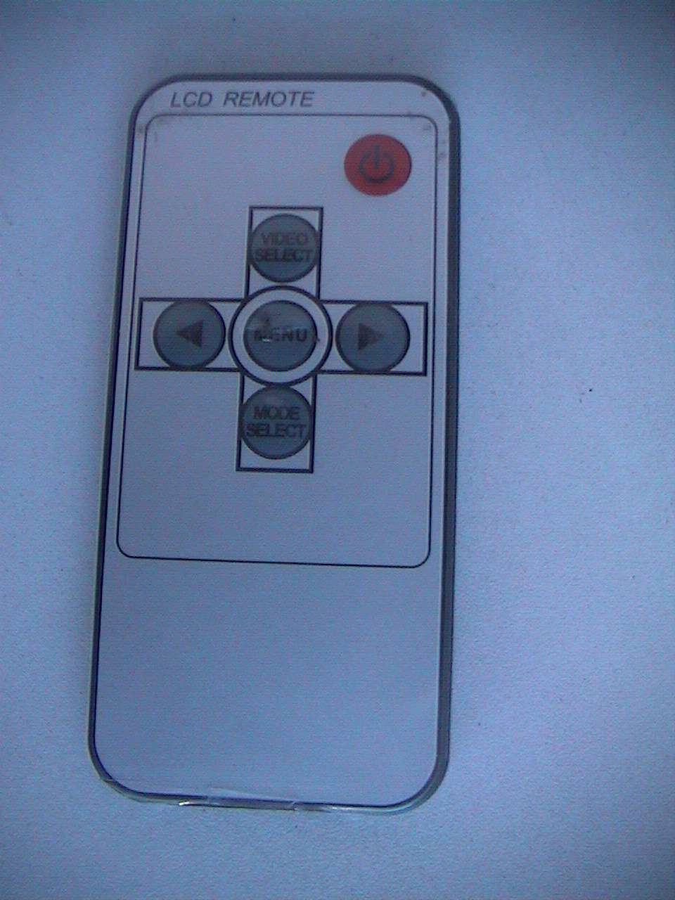
1

2
3

4

5

6
1:POWER SWITCH
2:VIDEO SELECT SWITCH:VGA/AV1/AV2/FM
3:MENU SWITCH
4:MENU"OSD+"
5:MUTE SWITCH
6:MENU"OSD-"
Connection guide
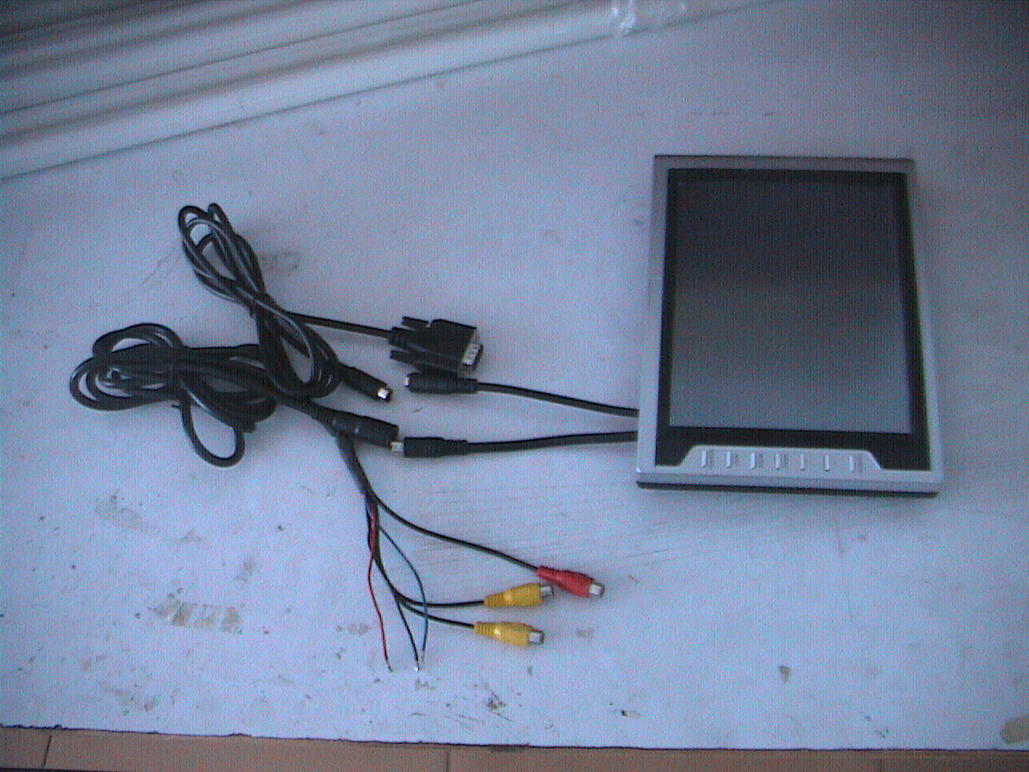
1

2

3

4
5
6 v 7 8 9 10 11

1:Port to Connect with PC port 2:Port of input VGA (hollow S Port )
3:Port to Connect with display (bulgy S port) 4:Port of input video (hollow S Port)
5:Port of input video (bulgy S Port) 6:ACC+12V(RED)
7:GROUND(BLACK) 8:TO BACK A CAR(BLUE)
9:VIDEO1(YELLOW) 10:VIDEO2(YELLOW)
11:AUDIO(RED)

Cautions
Please read the manual carefully &completely before you use
the car audio system, and follow the cautions listed below.
- In order to avoid fire or electric shock, don’t expose the unit under
rain or damp.
- Don’t open the unit for personal repairing. Any problem, please
shut off the unit and contact with our supplier.
- Don’t expose the unit under dust, oil or sun.
- Don’t use clearer to clean the unit, please use the fabric to clean
the dust .
5. Avoid dropping or impacting the machine and avoid knocking at the screen.
- For your safety, do not turn on, watch and operate the machine
when you are driving , in some countries and regions , it may be
against the laws.
- Safe power supply: DC 12V (10V—14V)

Guide to install touch function
Instruction for hardware drive installation
Precaution before installation
Make sure controller connected well with computer, and put CD into CD-ROM before installation. Moreover, install hardware drive first, then software drive.
1： Connect controller with computer USB port, select “my computer”, click right key to select “attribute”, then look over facility manager under the hardware menu.
2： Without installation of hardware drive, computer cannot identify this equipment consequently.
3： If you can’t find the port “COM3” , please first install USB drive software “cp210x_Drivers”.NOTICE!! (installing USB drive software will automatically create matching installation catalogue, the driver installation catalogue may be different in different computer , for example : the driver installation catalogue in some computers is “C:\SiLabs\MCU\CP210x”，but the driver installation catalogue in other computers is “C:\Program Files\SiLabs\MCU\CP210x”)
4： Select “CP2102 USB to UART Bridge Controller” under other facility menu ,click right key to select “update drivers” .
5：Select “install from list or designated place ” option under hardware update guide interface, click “next ”, select “ browse ” menu , select matching driver under the third step of installation catalogue ,for example ,if the system is XP ,you should choose such catalogue:
If the catalogue in the 3rd step is C:\ProgramFiles\SiLabs\MCU\CP210x
the directory in this place you should choose is ：C:\ProgramFiles\SiLabs\MCU\CP210x\WIN
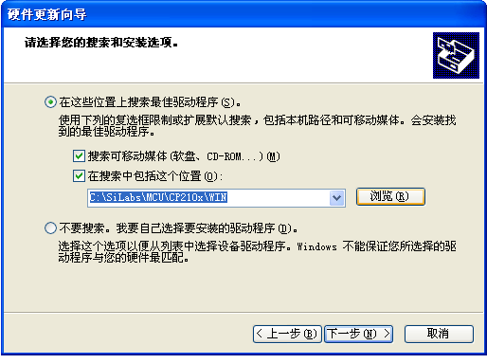

6： If system testing appears in the installation, please select “still continue” to keep on the process.
7： If you install it successfully, you will find message port “Com3” ,otherwise, please reinstall according to above steps .

Instruction for software drive installation

Precaution before installation
Before installing software drive, make sure that the hardware drive has been installed successfully and the CD has been put into computer correctly. Since computer will automatically scan for hardware equipment when installing software drive, please connect hardware equipment before installing software (that is to say, connect controller with USB port well).

1：Open files ,select the software named “sw500930”to decompress . Notice : “sw500930” software is used in XP or 2000 system , there is menu hint when decompressing it . “sw500085”software is used in 98、95、98SE and ME system , please select matching driver when installing it .
2： After decompressing successfully , installation interface appears automatically ,please select “install serial Touch screen Drivers” dialog column ,click “Next” to continue
3： Select “Yes” to confirm this installation agreement ,then click “Next” , select “Auto-detect ELO devices”option , enter port to select section, then select “com3”(because our controller is “Com3”) ,click “Next ” to continue .
4： A interface appears after installation , click “Finish”to exit .
5： To use computer normally , please restart computer after finishing installation.

Software operation process
Note: if the dot is pointed defectively, the revision will be wrong, please point each dot correctly when revising dot.
1：Open “control panel ” from “in my computer” ,select “Elo Touch screen”and open it ,enter software operation interface .
2：Select “Align” from “General” ,enter revision interface. (touch pen should point to the center of each dot when revising dot)
3：Select “Mode”, “Click on Touch” means click mode, “Click on release” means drag mode, “Mouse emulation” means mouse mode, “Hide arrow mouse pointer” means hiding mouse , “Left-handed mouse” means left and right key cross-over, “Show tool tray utility” means showing tool icon in status bar .
4：Select own favorite touch sound in sound menu.

Trouble Shooting
If you suspect something wrong, switch power off immediately.
Do not use the unit in abnormal condition, for example without sound or with smoke or fuel smell can cause fire or electric shock, immediately stop using it and call the store where you purchased it. Never try to repair the unit by yourself because it is dangerous to do so.

The phenomena listed below do not indicate that:

Wrong connection with polarity (+,-) ?

一、no electricity
Check the line and insert the S Port again.

The brightness and contrast are not adjusted properly?
二dark picture
Please adjust menu setting again.

No software of touch?
三、no touch
Reinstall the software of touch

No enough emendation?
四、deflective touch
Do emendation with 4or 25points again

